**Wi-Fi MODULE - ESP8266**

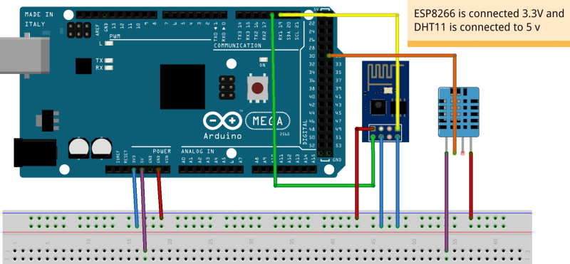

* Connect the ESP8266 Wi-Fi module and the DHT11 temperature sensor to the Arduino board as shown
* Using a USB cable connect board to the laptop
* Enter the below code, compile and upload
* Press on → Tools

→ Serial monitor

* If the serial monitor output displays ‘OK’

the connection to the server was successful

#include <SoftwareSerial.h>

#define RX 10

#define TX 11

String AP = "oppo f7"; // CHANGE ME

String PASS = "123456789"; // CHANGE ME

int countTrueCommand;

int countTimeCommand;

boolean found = false;

int valSensor = 1;

String HOST = "173.255.227.48";

//String HOST = "192.168.0.7";

String PORT = "9999";

int Sensor_Val = 0;

SoftwareSerial esp8266(RX,TX);

void setup() {

Serial.begin(9600);

esp8266.begin(115200);

sendCommand("AT",5,"OK");

sendCommand("AT+CWMODE=1",5,"OK");

sendCommand("AT+CWJAP=\""+ AP +"\",\""+ PASS +"\"",20,"OK");

}

void loop() {

delay(10000);

Sensor_Val = analogRead(A0);

String getData = "MOISTURE_DATA="+String(Sensor_Val);

Serial.println(getData);

sendCommand("AT+CIPMUX=1",5,"OK");

sendCommand("AT+CIPSTART=0,\"TCP\",\""+ HOST +"\","+ PORT,15,"OK");

sendCommand("AT+CIPSEND=0," +String(getData.length()),4,">");

esp8266.println(getData);

delay(1500);

sendCommand("AT+CIPCLOSE=0",5,"OK");

}

void sendCommand(String command, int maxTime, char readReplay[]) {

Serial.print(countTrueCommand);

Serial.print(". at command => ");

Serial.print(command);

Serial.print(" ");

while(countTimeCommand < (maxTime*1))

{

esp8266.println(command);//at+cipsend

if(esp8266.find(readReplay))//ok

{

found = true;

break; }

countTimeCommand++;

}

if(found == true)

{

Serial.println("OK");

countTrueCommand++;

countTimeCommand = 0;

}

if(found == false)

{

Serial.println("Fail");

countTrueCommand = 0;

countTimeCommand = 0;

}

found = false;

}